Synthetic Data Generation User Guide

  - Avionics Test and Analysis Corporation
  - Updated March 2025
Contents
Introduction 3
Environment 3
BlueMax7 3
X-Plane 12 3
SyntheticData Project 3
Scenario 3
Data Generation 5
Convert to SQLite Database 5
Video Generation with X-Plane 12 5
Set up X-Plane 5
Check UDP 5
Test Video Output 6
Additional Tips 6
Generating Flight Video 6
Generate Chapter 10 7
Verification 7
Batch Commands 7

Introduction
This user guide provides process overview and troubleshooting information for engineers tasked with generating data using the Synthetic Data project.
In addition to general information, this guide gives suggestions and values used with respect to the “Simultaneous Four” synthetic data generation scenario tasking. These values (highlighted in blue) may require changes to accommodate current tasking or other needs.

Environment

BlueMax7
BlueMax7 is the tool of choice to generate flight data for custom scenarios.
Place the contents of the BlueMax7.2 DVD or full directory at a location on a local storage drive—recommend “C:\Bluemax7.2”. Modify relevant values in the .config file “BlueMax7.2\Bin\BlueMax.config” to reflect the installation directory.

X-Plane 12
X-Plane 12 provides a visualization engine to replicate flight scenarios with current-generation graphics. The engine can be driven by generated flight data, and the renders are captured to compose the desired flight video data.
Follow X-Plane installer instructions to install X-Plane on the local machine.

SyntheticData Project
A local Visual Studio 2019 C++ development environment is required to build the SyntheticData project.
- Clone the repository: https://github.com/atac/SyntheticData.git
- Open the Visual Studio solution “SynthData.sln”
- Build the solution to generate all binaries
Note: At this time, additional steps may be needed to properly link 3rd party libraries.

Scenario
BlueMax7 provides a graphical user interface to aid in scenario generation. The information in this section provides an overview of this process. See the user manuals for more detailed information.
- Start the BlueMax7GUI.exe application
- Click “Start New Scenario”
- In the subsequent dialog, select F-15A aircraft and provide a call sign and entity ID
- In the Scenario Setup panel, select “Initial Conditions”
  - Set the Reference Zulu Time
  - If incorporating a takeoff or landing, choose “Constant Elevation”
  - Set any relevant values in “Aircraft Initial Conditions”
- Select “Output Files” and check the following
  - Mission
  - Route
  - User Defined
    - Add the following line to the scenario just before the “InitializeBlueMax” command:
UserVariable actime aclatd aclond acaltf acphid acthtad acpsid acvxi acvyi acvzi acaxi acayi acazi acaoad acnzb acmagd acktas cmthro acgear
- Add Flight Segments as desired (see Simultaneous Four .scn files for examples)
- Generate flight data by clicking “Run BlueMax 7”. The CSV output is written to a file with a “_UDO.txt” suffix.
To verify flight data, click “View Plots”, select the appropriate plot file, and check the plots for any relevant data (e.g. lat/lon, altitude, airspeed, roll, pitch, etc.). For a simple visualization of the flight, click “Run HIVE”. A visual simulation will begin which enables verification of aircraft movements.
The BlueMax7 autopilot may cause occasional erratic behavior when switching waypoints or headings. If this occurs, the user may need to adjust maneuver limits and use a combination of “Autopilot” and “Sustained” limit types. It can also help to avoid giving commands that change multiple parameters (heading, speed, and altitude) simultaneously. Try changing a single parameter at a time (e.g. heading first then altitude).
If multiple aircraft are needed, create a new scenario for each one paying attention to the start time for flight coordination.
  - Note: The takeoff elevation may need to be adjusted slightly to align with X-Plane terrain models.

Data Generation

Convert to SQLite Database
Once flight data has been generated for all flights, it must be converted to an SQLite database table. BM6toDB.exe is used to accomplish this with the following Command Prompt command (see also Batch Commands):
BM6toDB.exe <input_flight_data> <output_db>

Video Generation with X-Plane 12
X-Plane 12 provides a flight simulator and modern visualization platform. For the purposes of this project, the simulator is fed aircraft positioning data line-by-line, and a screen capture is taken at each frame. The capture data is encoded and stored in the SQLite database, row-aligned with the existing flight data.

Set up X-Plane
BM6toXPlaneVideo.exe drives, records, and encodes the simulation, but X-Plane must be manually set up for proper execution. Use the following steps:
- Start X-Plane
- Click “New Flight”
- Under Aircraft, choose “F-4 Phantom II”
- Under Location, search “Nellis AFB”
- Double-click the entry and choose “Runway 3L”
- Click Confirm
- Set weather and time of day
- Click “Start Flight”
X-Plane is now ready to accept flight data over UDP.

Check UDP
To confirm X-Plane is receiving UDP messages from BM6toXPlaneVideo.exe, start a flight and open the Network tab of Settings. In the “Receiving Data From” section, there will be a line that reads “Multiplayer machine flying (127.0.0.1)”. This means X-Plane is receiving valid aircraft input over the network.
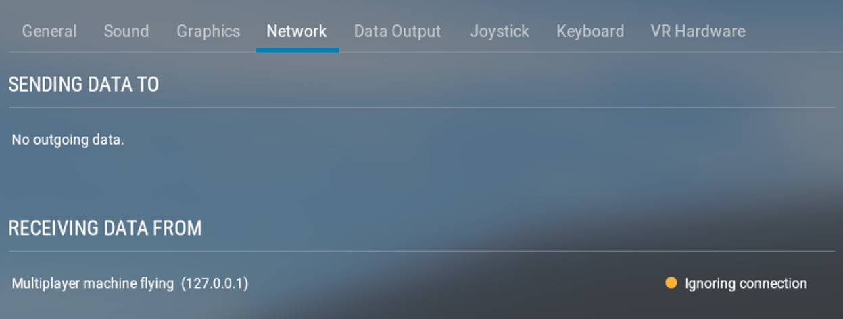
If this does not appear, there may be a configuration issue. Make sure the “Port we receive on (legacy)” field is set to 49000.

Test Video Output
Test the video recording by dumping the output to an MP4 file for verification. Use the -M option to perform the dump (see also Batch Commands).
BM6toXPlaneVideo -t <input_flight_data> -M <output_video_pathname>

Additional Tips
Saving a situation can reduce setup time when a recording session takes longer than one sitting. Wait until the new flight is loaded and choose “Save Flight” from the menu. Choose a name and destination and click save. To load a situation, click “Load Saved Flight” from the main menu.
At any point, and between recording passes, press Ctrl+; to reset to the flight’s starting point.
The synthetic data generator expects three views for each flight: cockpit, HUD, and chase. Use the following shortcuts to assist in positioning the view prior to recording:
- Shift+9 for cockpit
- Shift+w for HUD
- Shift+8 for chase
  - Mouse or arrow keys to rotate view

Generating Flight Video
After X-Plane setup and recording verification, the video is ready to be recorded into the database. Position the running X-Plane window on the primary display, then use the following command (see also Batch Commands):
BM6toXPlaneVideo -t <input_flight_data> -D <output_db> -T <video_table_name>
The -t option can be repeated for as many additional aircraft as needed, but the first one listed will be the primary POV.
The -D option should be the same SQLite database generated in the previous step.
The -T option should be one of “Video_HUD”, “Video_F4_Cockpit”, and “Video_F4_Chase” depending on the chosen perspective.
BM6toXPlaneVideo will pause for 2 seconds prior to starting the recording session. This provides an opportunity to isolate the X-Plane window on the primary screen for screen capture. X-Plane should then begin adjusting the aircraft position based on the UDP input and each frame captured into the SQLite database.

Generate Chapter 10
Once all videos have been recorded, the final step is to synthesize the Chapter 10 files using the SQLite database tables as input. Use SynthCh10Gen-BM6.exe for this purpose with the following command (see also Batch Commands):
SynthCh10Gen-BM6 -v -b <input_db> <output_ch10_pathname>
The SQLite database will be used to populate the Chapter 10 packets, and the fully formatted Chapter 10 file will be written to disk.

Verification
The latest version of DPS (ATAC-owned telemetry processing software) is capable of processing these generated Chapter 10 files in a fully automated manner by selecting Auto Mission from the Tools menu. Provide the Chapter 10 file and an output directory and click Run. All data channels will be processed into EU CSV files, and MP4 videos will be generated for each video channel.

Batch Commands
The following is an example of batch commands that can be used to reduce typing/typos when generating multiple files as in the case of the “Simultaneous Four” task.
Set these variables to properly link the required 3rd party DLLs:

set exedir=C:\atac\vsprojects\SyntheticData\Release
set PATH=%PATH%;%exedir%\..\3rdParty\ffmpeg\bin;
‘cd’ to the working directory containing the BlueMax7 “_UDO.txt” files:
cd C:\data\synthetic\simulfour
Set up these variable sets to easily access filenames:
set in1=Simultaneous_Four_1_UDO.txt  set db1=simulfour1.sql  set ch10_1=simulfour1.ch10  set in2=Simultaneous_Four_2_UDO.txt  set db2=simulfour2.sql  set ch10_2=simulfour2.ch10  set in3=Simultaneous_Four_3_UDO.txt  set db3=simulfour3.sql  set ch10_3=simulfour3.ch10  set in4=Simultaneous_Four_4_UDO.txt  set db4=simulfour4.sql  set ch10_4=simulfour4.ch10 | # the input flight data  # the output SQLite DB  # the output Chapter 10 file
Use these collections to simplify including multiple flight data input files (remember the first one listed will be the primary POV):
set collection1=-t %in1% -t %in2% -t %in3% -t %in4%
set collection2=-t %in2% -t %in3% -t %in4% -t %in1%
set collection3=-t %in3% -t %in4% -t %in1% -t %in2%
set collection4=-t %in4% -t %in1% -t %in2% -t %in3%
Set general variables for the current primary flight.
For flight 1:
set infile=%in1%
set db=%db1%
set ch10=%ch10_1%
set collection=%collection1%
For flight 2:
set infile=%in2%
set db=%db2%
set ch10=%ch10_2%
set collection=%collection2%
And so on…
Then for each flight:
- Convert flight data to SQLite database
%exedir%\BM6toDB %infile% %db%
- Generate video (adjusting X-Plane POV for the correct view prior to each command)
%exedir%\BM6toXPlaneVideo %collection% -D %db% -T Video_HUD
%exedir%\BM6toXPlaneVideo %collection% -D %db% -T Video_F4_Cockpit
%exedir%\BM6toXPlaneVideo %collection% -D %db% -T Video_F4_Chase
- Generate Chapter 10 file
%exedir%\SynthCh10Gen-BM6 -v -b %db% %ch10%

